Body Pro-Lok ONE™ System
with ONEPlatform™ or Universal Couchtop™
Patient |  | Date
Notes

IMPORTANT INSTRUCTIONS, PLEASE READ:
When indexing to the Universal Couchtop, use the indexing marks along the side of the couchtop for indexing Lok-Bars™ and the indexing marks along the top of the couchtop for indexing Body Pro-Lok ONE devices.
- When transferring a setup from the Universal Couchtop or ONEPlatform to the Body Pro-Lok ONE Rails-Only System, the ONEBridge™ must be adjusted and set 50 mm lower than on the Universal Couchtop or ONEPlatform*.
- When transferring a setup from the Universal Couchtop or ONEPlatform to the iBEAM® evo Couchtop with the Body Pro-Lok ONE evo Adapter, reference Appendix A for available setup regions*.
*Separate set-up sheets for Body Pro-Lok ONE Rails-Only and evo Adapter are available.

If utilizing the ONEPlatform, start at #1
If indexing directly to the Universal Couchtop, start at “Respiratory Plate” (page 2)
Lok-Bars for indexing the ONEPlatform are indexed to table at
Lateral Lok-Bar Position | ☐ F ☐ G ☐ H
Lateral Position (only if using a Transverse Lok-Bar)
Head end indexed at: |  | Foot End Indexed at:
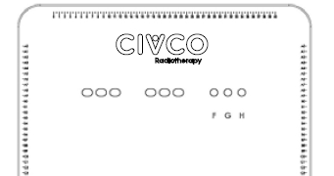 |  | 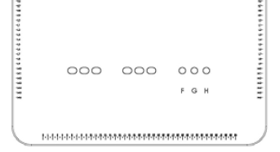

Respiratory Plate Used | ☐ Standard ☐ Wide ☐ ComfortCare™ Cushion
1) ONEBridge Side A
2) ONEBridge Side B
3) Docking Index
4) ONEBridge Lateral Position
5) Respiratory Plate Height
6) Respiratory Plate  Lateral Position | ☐ D  ☐ C  ☐ E
If using ComfortCare Cushion with  Wide Respiratory Plate)  7) Set pressure between | &

Respiratory Belt Used? | ☐ Yes  ☐ No
1) Docking Index
2) Left velcro strap indexed at
3) Right velcro strap indexed at
4) Set pressure between | &

Patient hAND GRIPS USED? | ☐ Yes ☐ No
rIGHT HAND GRIP INDEXED AT |  | lEFT HAND GRIP INDEXED AT

Bridge with Clam-Lok  Cushion Used? | ☐ Yes  ☐ No | 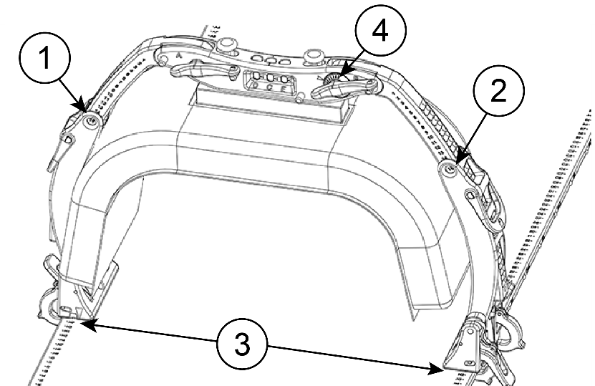
1) ONEBridge Side A
2) ONEBridge Side B
3) Docking Index
4) ONEBridge Lateral Position

KneeFix Used? | ☐ Yes ☐ No | Indexed To  PLATFORM AT
Feetfix Used? | ☐ Yes ☐ No | Indexed To  PLATFORM AT
flexlock knee support used? | ☐ High ☐ Low | Indexed To  PLATFORM AT
 |  | location of knee support on Locating Bar | ☐A ☐B ☐C ☐D  ☐E ☐V ☐W ☐X  ☐Y ☐Z
Flexlock feet support used? | ☐ Yes ☐ No | Indexed To  PLATFORM AT
 |  | location of feet support on locating bar | ☐A ☐B ☐C  ☐D ☐E
 |  | Angle of Feet Support | ☐0° ☐5° ☐10°  ☐15° ☐20° ☐25°  ☐30°
 |  | leg and Foot Strap used? | ☐ Yes ☐ No
Additional indexable accessory |  | Indexed To  PLATFORM AT
Additional indexable accessory |  | Indexed To  PLATFORM AT

