Body Pro-Lok ONE™ System  with TotalRT™ Platform |  | 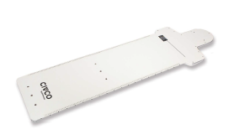
Patient |  | Date of Birth
Notes

Lok-Bars for indexing the Platform are indexed to table at
Wing Board Used? | ☐ Yes ☐ No | Hand Grips Indexed at
Headrest Used? | ☐ Yes ☐ No
Vac-Lok Used? | ☐ Yes ☐ No | Vac-Lok Lok-Bar Indexed at
Respiratory Plate Used | ☐ Standard ☐ Wide ☐ None (skip to respiratory belt section)

1) ONEBridge Side A
2) ONEBridge Side B
3) Docking Index
4) ONEBridge Lateral Position
5) Respiratory Plate Height
6) Respiratory Plate
Lateral Position
If using ComfortCare Cushion with Wide Respiratory Plate)  7) Set pressure between | &

Respiratory Belt Used? | ☐ Yes  ☐ No
1) Docking Index
2) Left velcro strap indexed at
3) Right velcro strap indexed at
4) Set pressure between | &

Patient hAND GRIPS USED? | ☐ Yes ☐ No
rIGHT HAND GRIP INDEXED AT |  | lEFT HAND GRIP INDEXED AT

Bridge with Clam-Lok  Cushion Used? | ☐ Yes  ☐ No | 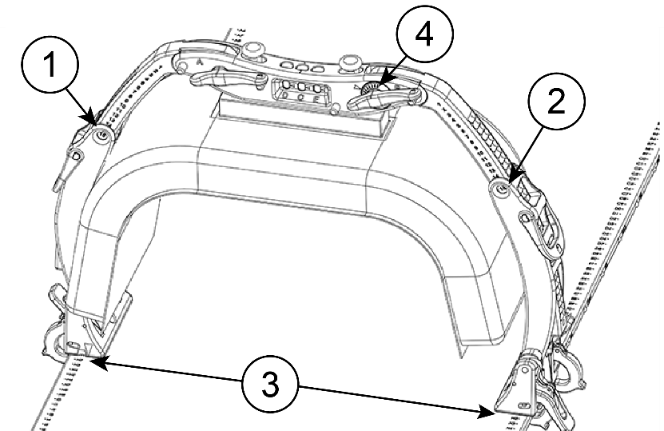
1) ONEBridge Side A
2) ONEBridge Side B
3) Docking Index
4) ONEBridge Lateral Position

KneeFix Used? | ☐ Yes ☐ No | Indexed To  PLATFORM AT
Feetfix Used? | ☐ Yes ☐ No | Indexed To  PLATFORM AT
flexlock knee support used? | ☐ High ☐ Low | Indexed To  PLATFORM AT
 |  | location of knee support on Locating Bar | ☐A ☐B ☐C ☐D  ☐E ☐V ☐W ☐X  ☐Y ☐Z
Flexlock feet support used? | ☐ Yes ☐ No | Indexed To  PLATFORM AT
 |  | location of feet support on locating bar | ☐A ☐B ☐C  ☐D ☐E
 |  | Angle of Feet Support | ☐0° ☐5° ☐10°  ☐15° ☐20° ☐25°  ☐30°
 |  | leg and Foot Strap used? | ☐ Yes ☐ No
Additional indexable accessory |  | Indexed To  PLATFORM AT
Additional indexable accessory |  | Indexed To  PLATFORM AT

