Thorawedge™ System |  |  | 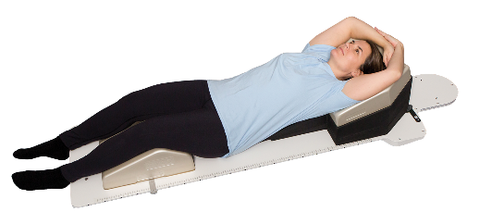
Patient |  | Date of Birth
Notes

- Thorawedge Locator Used: | ☐ Yes  ☐ No (If no, skip to #3)
- Lok-Bar Indexed at: |  |  | 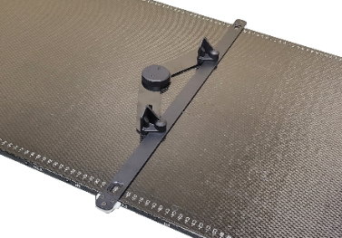
- Order of wedges (top to bottom)  5- or 10-degree wedges |  | ° | 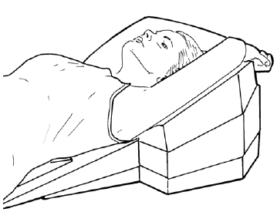
 |  | °
 |  | °
 |  | °
 |  | °
 |  | °
 |  | °
- Lumbar Support Orientation | ☐ 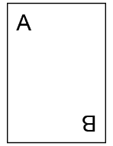 |  | ☐
- Position Lumbar Support | ☐ 7  ☐ 6  ☐ 5  ☐ 4  ☐ 3  ☐ 2  ☐ 1  ☐ 0 |  | 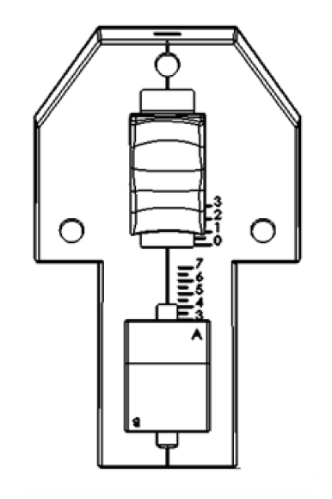
- Position Head Support | ☐ 3  ☐ 2  ☐ 1  ☐ 0

