ThermFix™ Immobilization System |  |  | 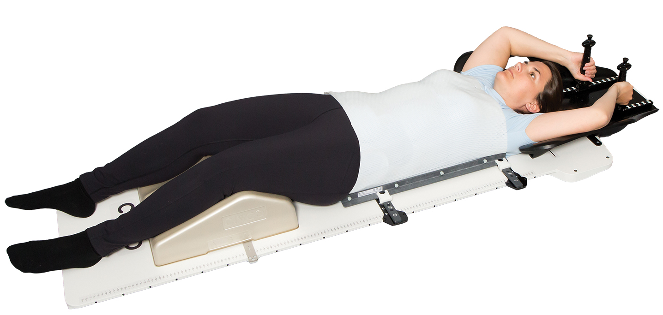
Patient |  | Date of Birth
Notes

Superior Bar 1  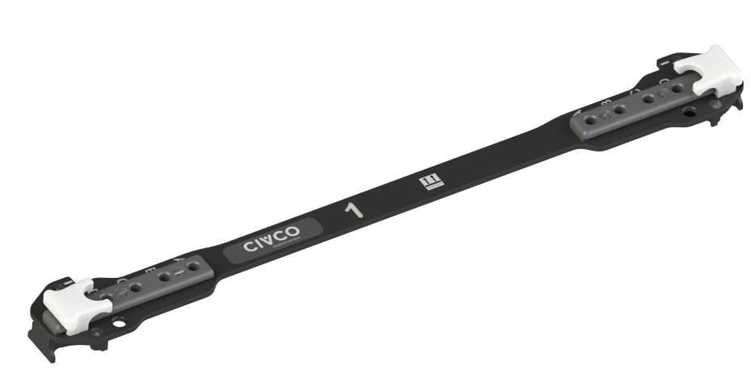 | Inferior Bar 2  (no central docking)  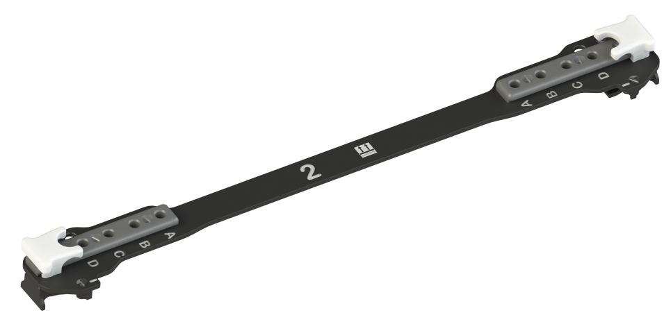 | Inferior Hip & Pelvic Bar 2  (with central docking)  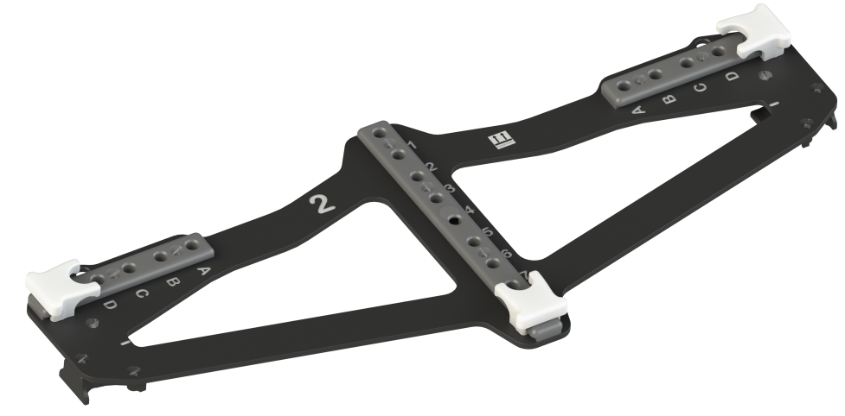

Bar Indexing (see blue arrows)
- Superior Bar 1 Indexed to couchtop at:
- Inferior Bar Used (choose one): | ☐ No central docking  ☐ Central docking
- Inferior Bar 2 Indexed
to couchtop at:

Thermoplastic Indexing
- Patient’s left side: | ☐ A ☐ B ☐ C ☐ D
- Patient’s right side: | ☐ A ☐ B ☐ C ☐ D
- Central Docking location (if used) | ☐ 1 ☐ 2 ☐ 3 ☐ 4 ☐ 5 ☐ 6 ☐ 7

