Evolve Breastboard |  | 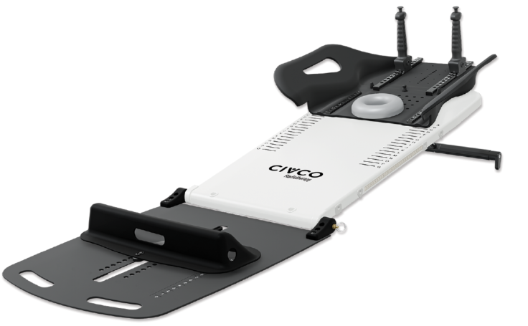
Patient |  | Date of Birth
Notes

- Lok-Bar indexed to table at

- Slant board elevation angle set at |  |  | - Bottom Board used? | ☐ Yes ☐ No
 |  |  | Bottom Stop Positioned at
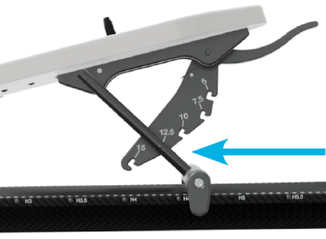 |  |  | 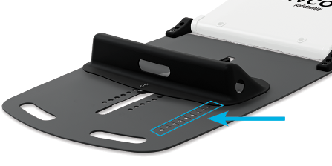

- Wing Board type |  | 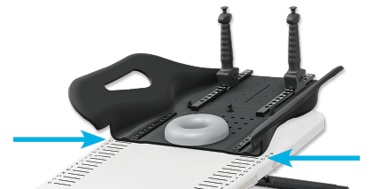
Wing Board Indexed at
Vac-Lok used? | ☐ Yes ☐ No
Headrest type |  | Indexed at
Handle type |  | Indexed at | Left: | Right:
Chin Thermoplastic used? | ☐ Yes ☐ No | Indexed at | ☐ A ☐ B

5) Breast Thermoplastic used? | ☐ Yes ☐ No | Indexed at | ☐ Square ☐ Heart
6) Laser Alignment Location

